1. Go EC2 dashboard – click on launch instance, select following free ubuntu server.

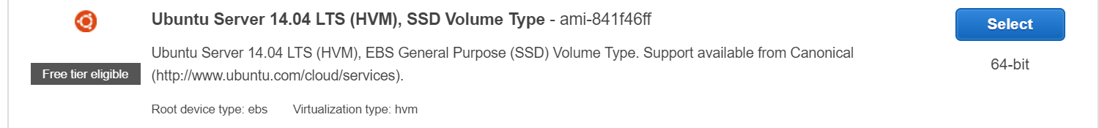

1. In step 6 add ssh and HTTP rule:

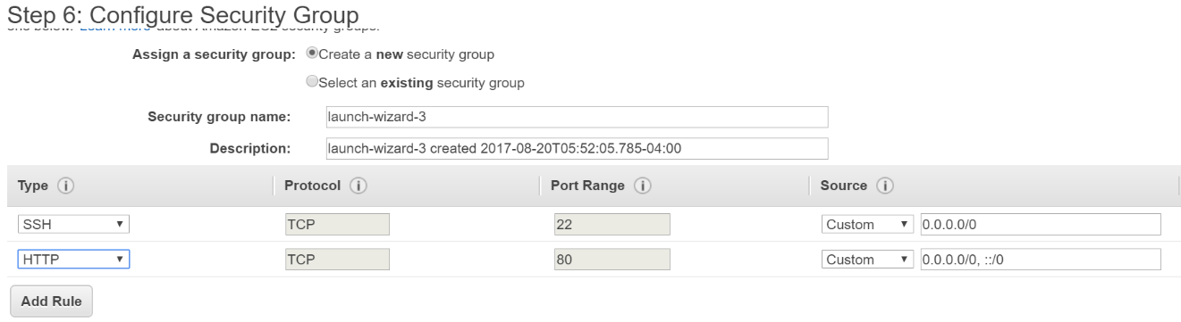

1. Click on launch, save key ( new create/existing)- server should be up soon.
2. Get Public IP address of the server from Dashboard ( clicking on running server) and Use the saved key to ssh to the server. You can use any client software for doing ssh ( putty, MobaXterm etc). Use user name “ubuntu” and add key file ( no password required then).
3. Sudo apt-get update
4. sudo tasksel install lamp-server // this will install mysql, apache, and php
5. to check apache running: type ip address/public DNS of the machine in the browser, you should see following page:
6. 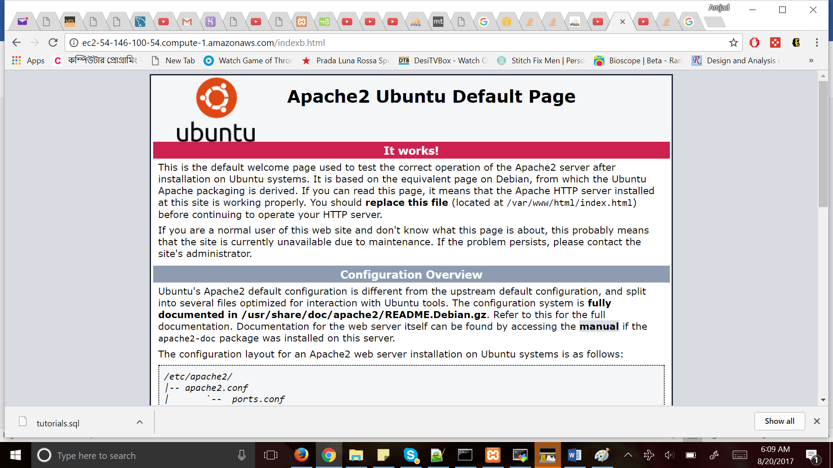
7. Go to /var/www/html, the index.html file you see there is for above page.
8. Yon can add any php/html file here and browse it from the browser. ( machine’s IP/page.html or page.php)
9. To use database install phpmyadmin for easy access/importing/creating database: sudo apt-get install phpmyadmin apache2-utils -- will ask for username and password for mysql. Same ID/password would be used everywhere later.
10. Access myphpadmin as: ip/myphpadmin
11. Now you should be able to create/import existing database and run php application as you run locally in Xampp.